**ONE CREDIT COURSE**

**PYTHON -DATA ANALYTICS**

**NAME: THANUSHREE K S**

**REG NO:927621BIT116**

**M.KUMARASAMY COLLEGE OF ENGINEERING ,**

**KARUR**

**HOUSING PRICE**

**Code:**

1. import numpy as np

import pandas as pd

2. dataset = pd.read_csv("housing_prices_SLR.csv") # first we need upload the dataset

dataset.head() # will shoe first 5 rows

3. x = dataset.iloc[:,0:1]

y = dataset.iloc[:,1]

x.head()

4. y.head()

5. from sklearn.model_selection import train_test_split

x_train,x_test,y_train,y_test = train_test_split(x,y,train_size=0.8,random_state=42)

6. from sklearn.linear_model import LinearRegression

model = LinearRegression()

7. model.fit(x_train,y_train)

8. samplepredciton = model.predict([[1240]])

print(samplepredciton)

9. y_pred = model.predict(x_test) # predicting for all x_test

y_pred

10. y_test

11. y_pred

12. list(zip(y_test,y_pred))

13. import numpy as np

# Hypothetical housing dataset

areas = np.array([1000, 1030, 1060, 1090])  # House areas in square feet

prices = np.array([5618, 5201, 4779, 5245])  # House prices in dollars

# Example of a simple linear regression model (hypothetical coefficients)

m = 200  # slope

b = 50000  # intercept

# Make predictions

predicted_prices = m * areas + b

# Calculate squared differences

squared_diff = (prices - predicted_prices) ** 2

# Calculate mean squared error

mse = np.mean(squared_diff)

print("Actual Prices:", prices)

print("Predicted Prices:", predicted_prices)

print("Squared Differences:", squared_diff)

print("Mean Squared Error:", mse)

14. from sklearn.metrics import r2_score

r2 = r2_score(y_test, y_pred)

print(f'R-squared score: {r2:.2f}

15. from sklearn.metrics import r2_score

r2 = r2_score(y_test, y_pred)

print(f'R-squared score: {r2:.2f}')

16. y_test

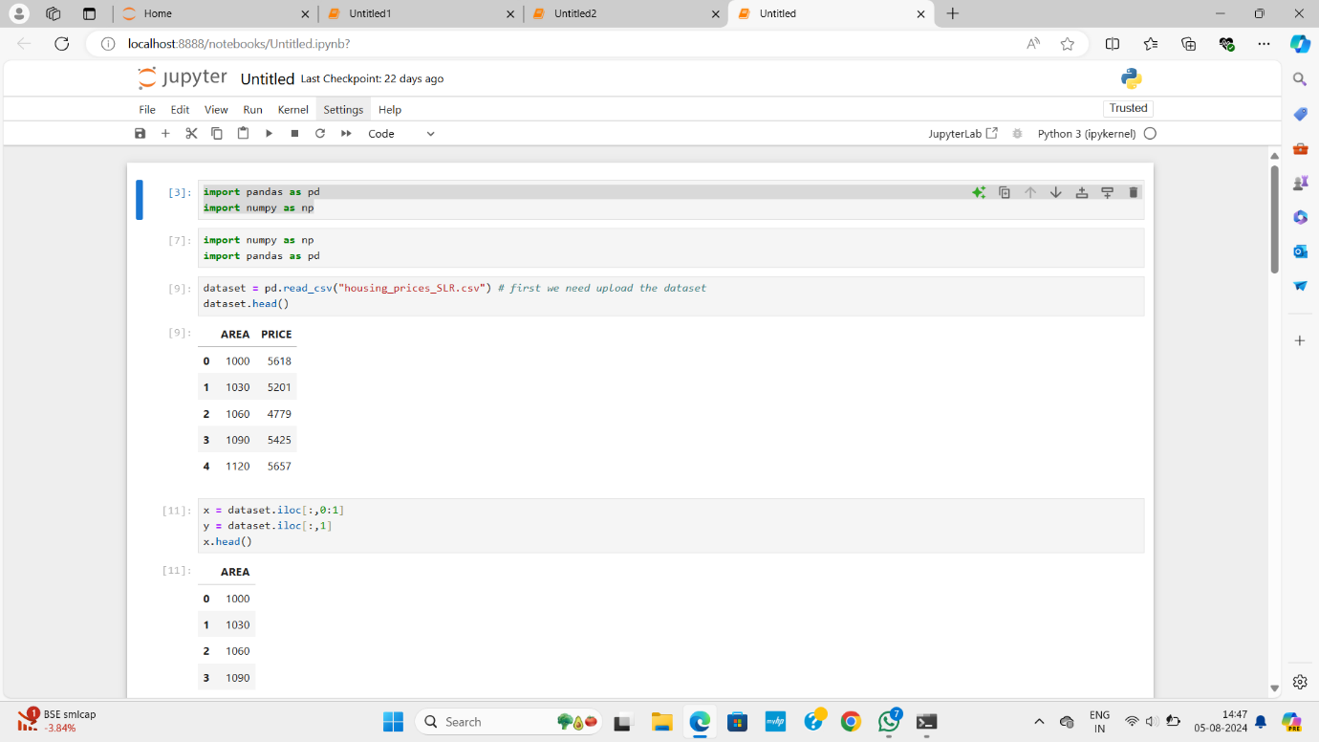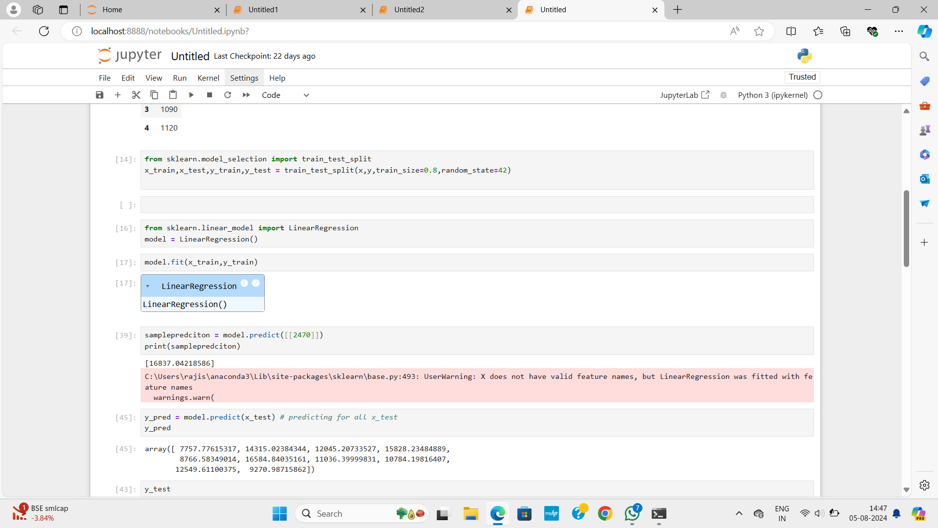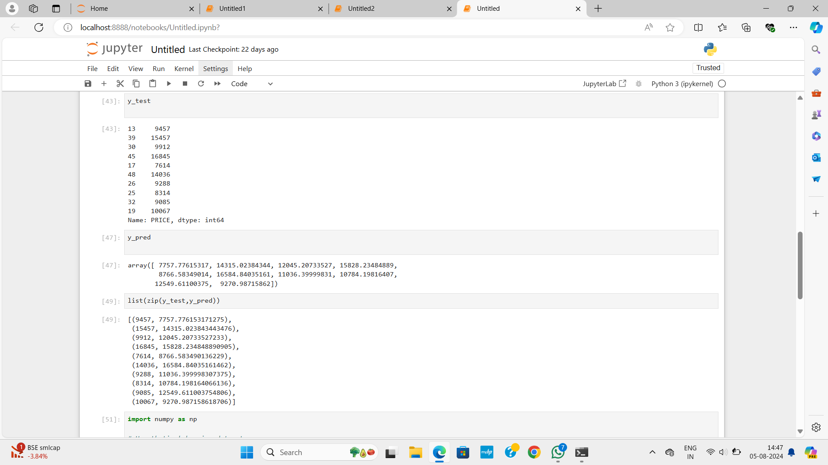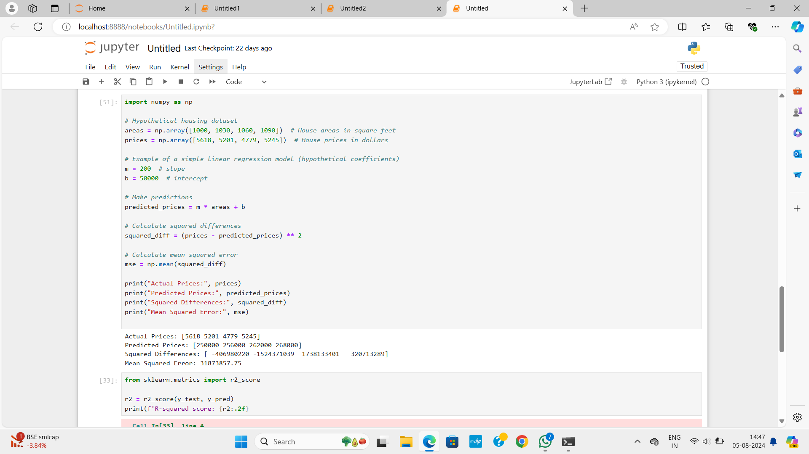

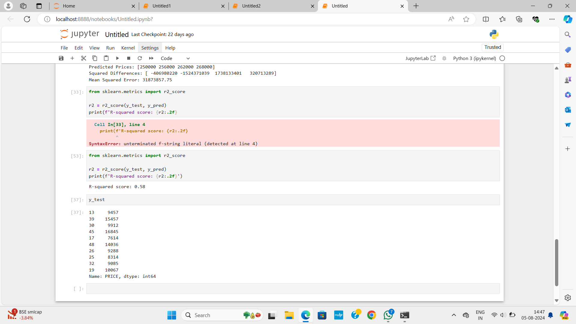

**MATRIX**

**Code :**

1. import pandas as pd

import numpy as np

2. dataset=pd.read_csv("Iris_dataset.csv")

3.dataset

4. x=dataset.iloc[:,1:5]

5.x

6. y=dataset.iloc[:,5:]

7.y

8. from sklearn.model_selection import train_test_split

x_train,x_test,y_train,y_test = train_test_split(x,y,train_size=0.8,random_state=42)

9. from sklearn.linear_model import LogisticRegression

model =  LogisticRegression()

10. model.fit(x_train,y_train)

11. model.predict([[5.1,3.5,1.4,0.2]])

12. y_test

13. y_pred

14. y_test

15. y_pred

16. from sklearn.metrics import confusion_matrix

conf_mat = confusion_matrix(y_test,y_pred)

print("Confusion Matrix:")

print(conf_mat)

17. import matplotlib.pyplot as plt

from sklearn.metrics import confusion_matrix, accuracy_score, classification_report, precision_score, recall_score, f1_score

conf_mat = confusion_matrix(y_test, y_pred)

plt.imshow(conf_mat, interpolation='nearest')

plt.title("Confusion Matrix")

plt.xlabel("Predicted Class")

plt.ylabel("Actual Class")

plt.colorbar()

plt.show()

plt.plot([accuracy, precision, recall, f1])

plt.xlabel("Evaluation Metric")

plt.ylabel("Value")

plt.title("Evaluation Metrics")

plt.legend(["Accuracy", "Precision", "Recall", "F1-score"])

plt.show()

18. import matplotlib.pyplot as plt

conf_mat = confusion_matrix(y_test, y_pred)

plt.imshow(conf_mat, interpolation='nearest')

plt.title("Confusion Matrix")

plt.xlabel("Predicted Class")

plt.ylabel("Actual Class")

plt.colorbar()

plt.show()

plt.figure(figsize=(10,5))

plt.subplot(1,2,1)

plt.plot([accuracy])

plt.xlabel("Evaluation Metric")

plt.ylabel("Value")

plt.title("Accuracy")

plt.show()

plt.subplot(1,2,2)

plt.plot([precision, recall, f1])

plt.xlabel("Evaluation Metric")

plt.ylabel("Value")

plt.title("Precision, Recall, F1-score")

plt.legend(["Precision", "Recall", "F1-score"])

plt.show()

19. import matplotlib.pyplot as plt

from sklearn.datasets import load_iris

from sklearn.model_selection import train_test_split

from sklearn.metrics import confusion_matrix

from sklearn.linear_model import LogisticRegression

iris = load_iris()

X = iris.data[:, :2]  # we only take the first two features.

y = iris.target

X_train, X_test, y_train, y_test = train_test_split(X, y, test_size=0.2, random_state=42)

scaler = StandardScaler()

X_train = scaler.fit_transform(X_train)

X_test = scaler.transform(X_test)

logreg = LogisticRegression()

logreg.fit(X_train, y_train)

y_pred = logreg.predict(X_test)

conf_mat = confusion_matrix(y_test, y_pred)

plt.imshow(conf_mat, interpolation='nearest')

plt.title("Confusion Matrix")

plt.xlabel("Predicted Class")

plt.ylabel("Actual Class")

plt.colorbar()

plt.show()

**Screenshots**

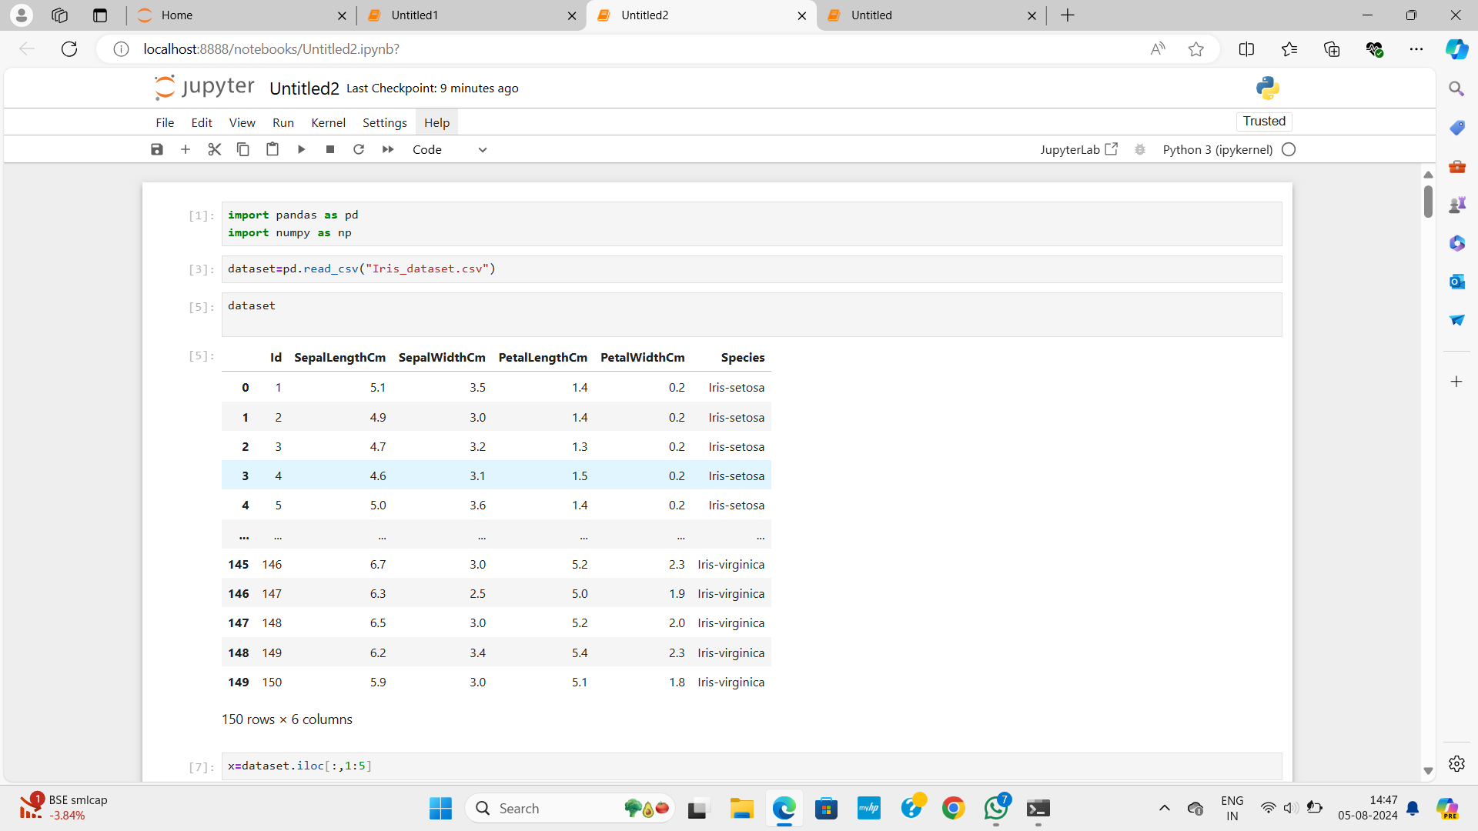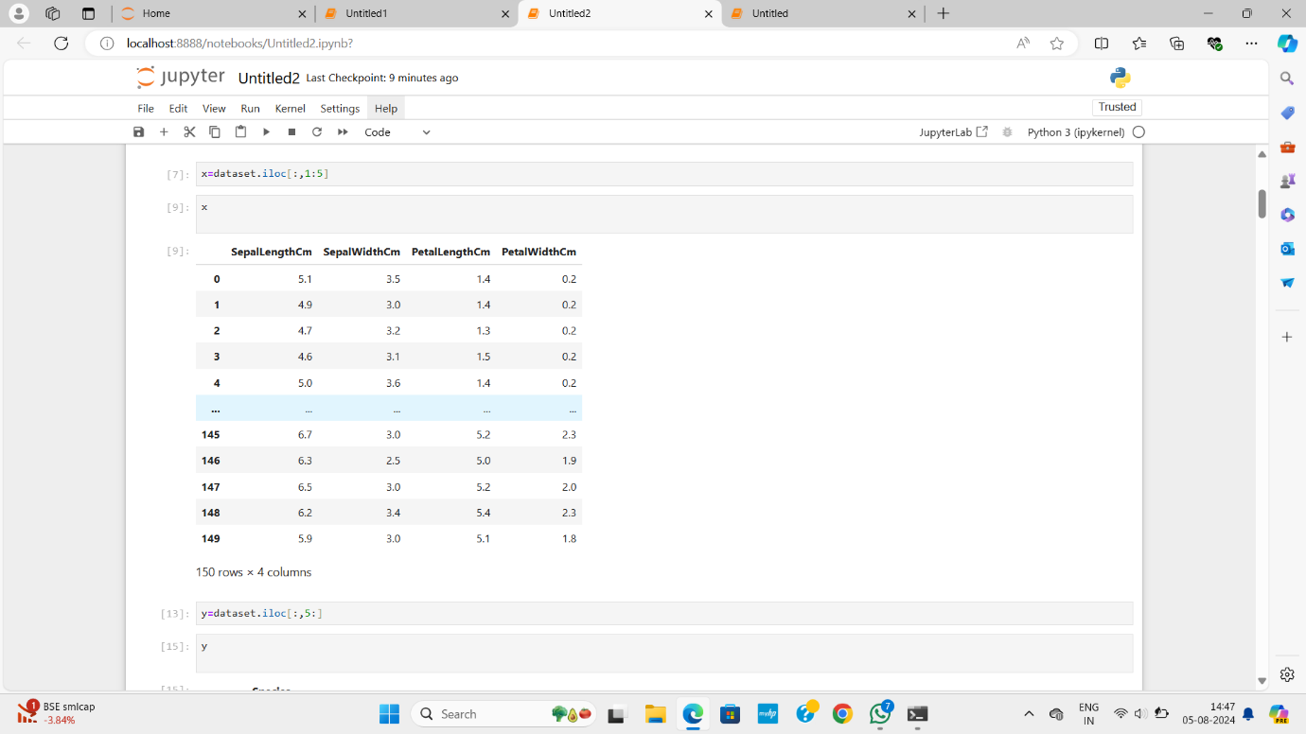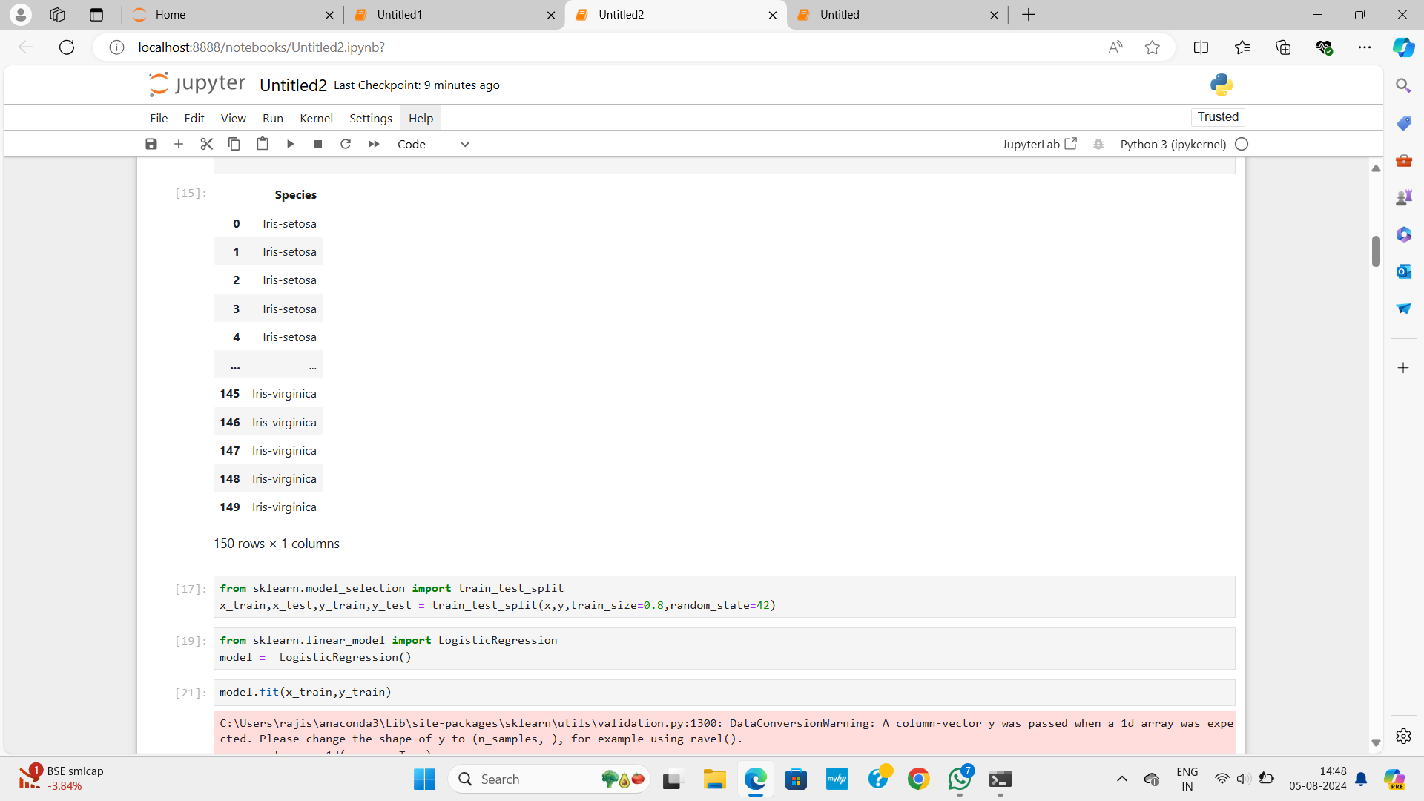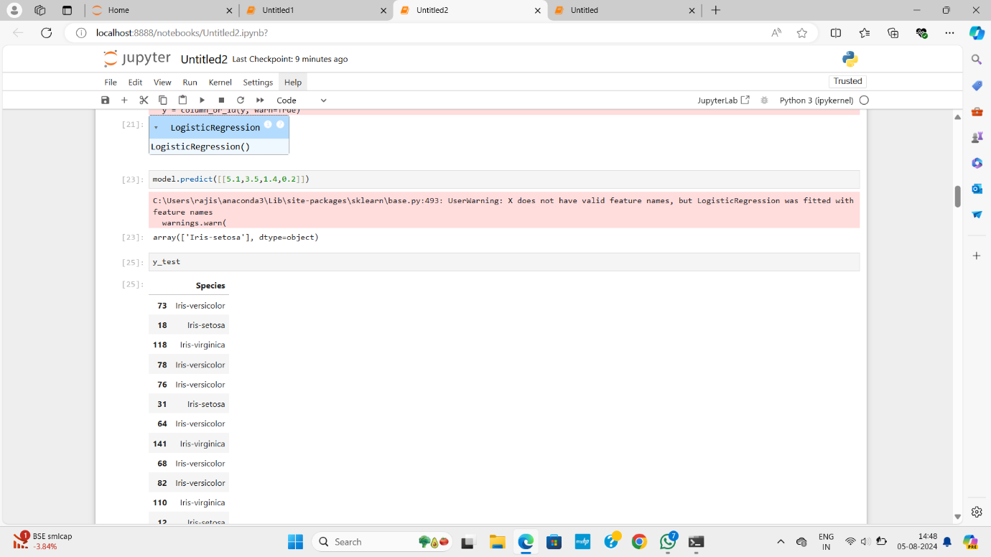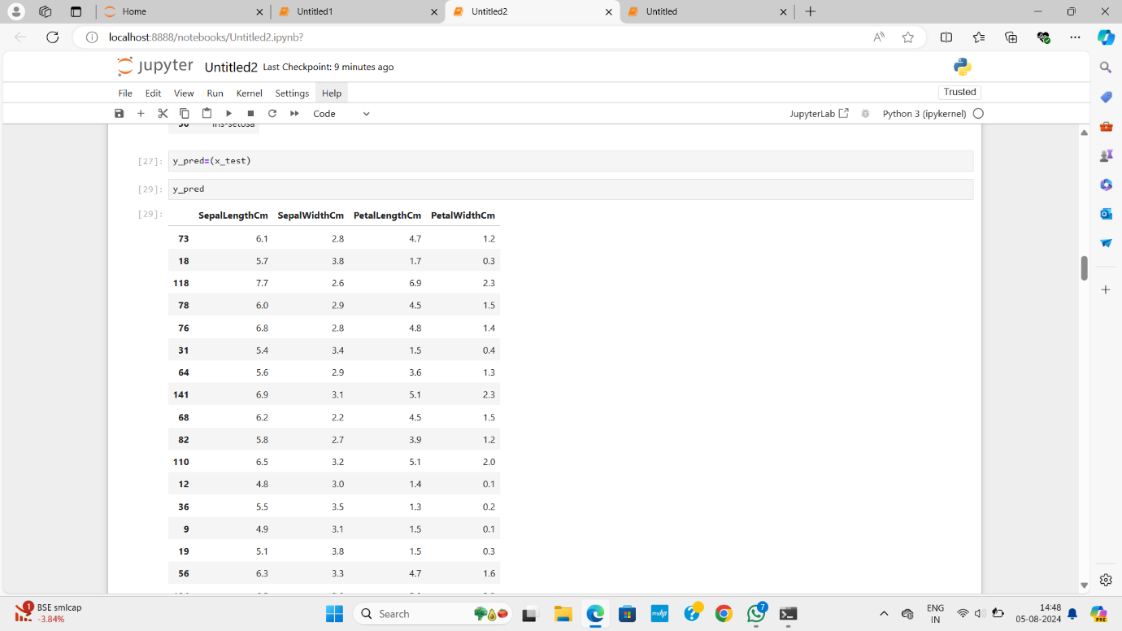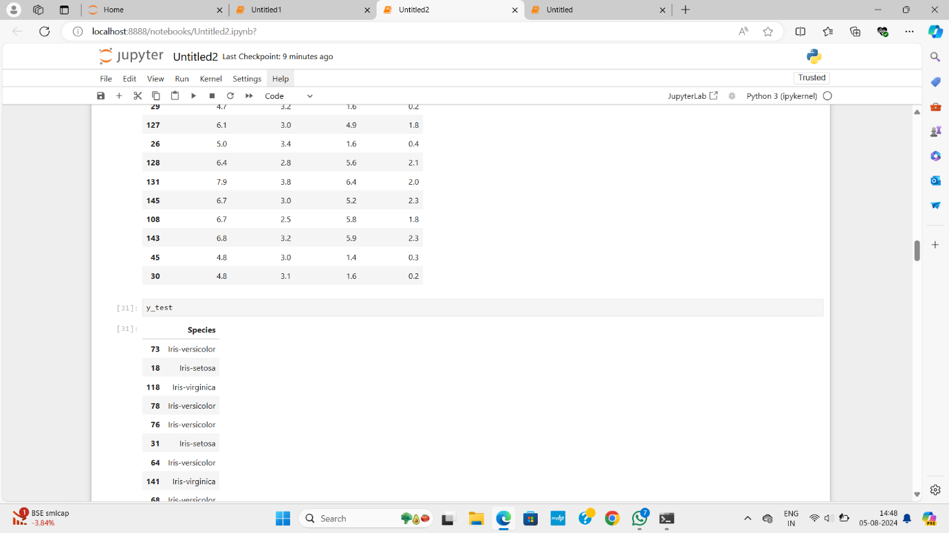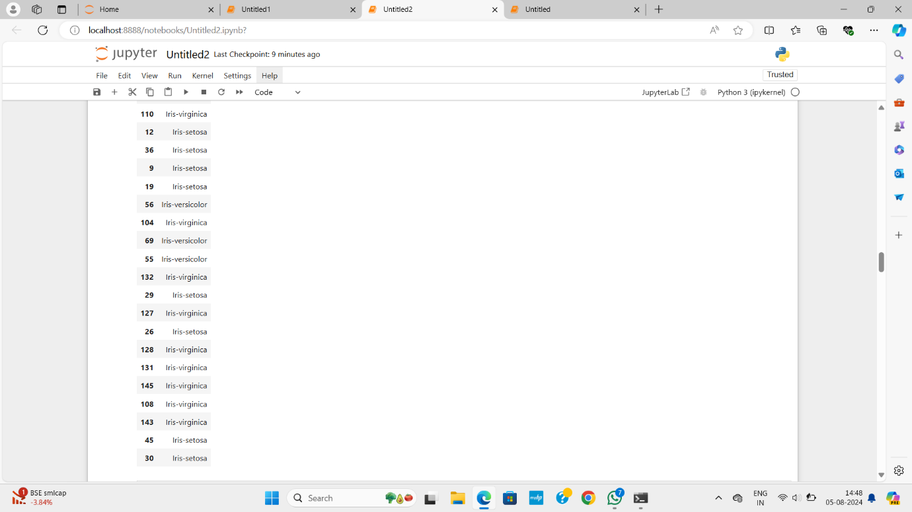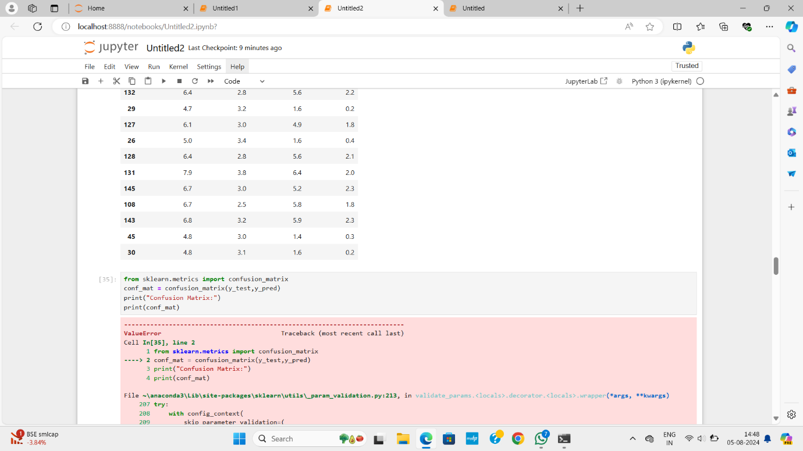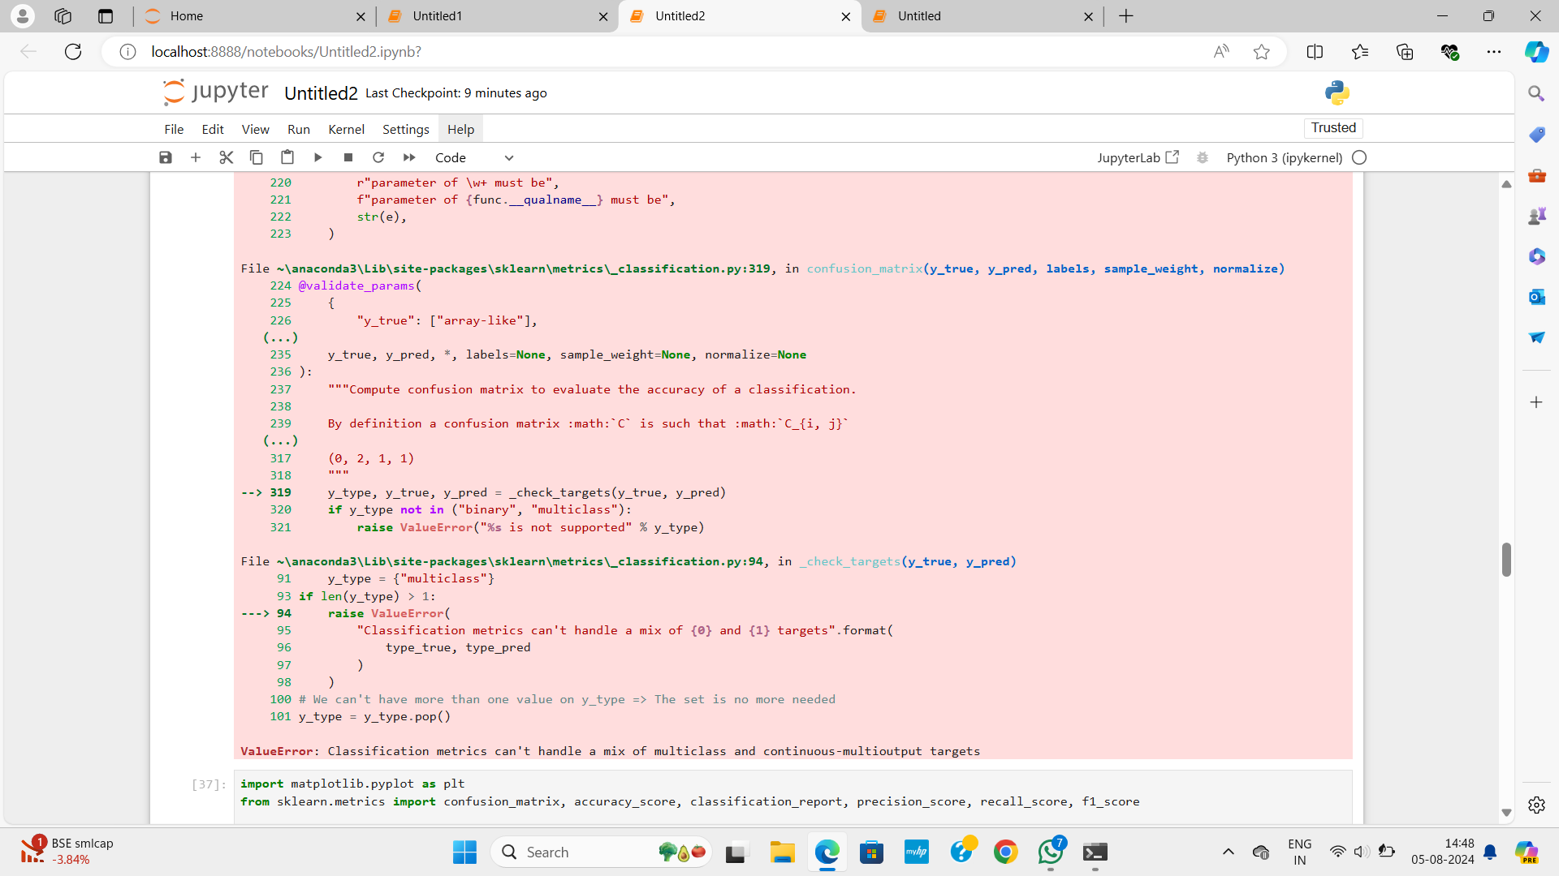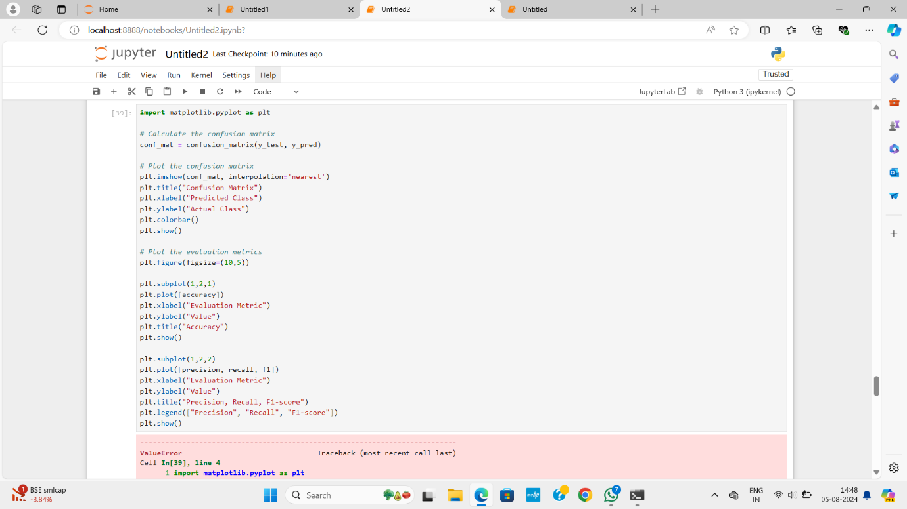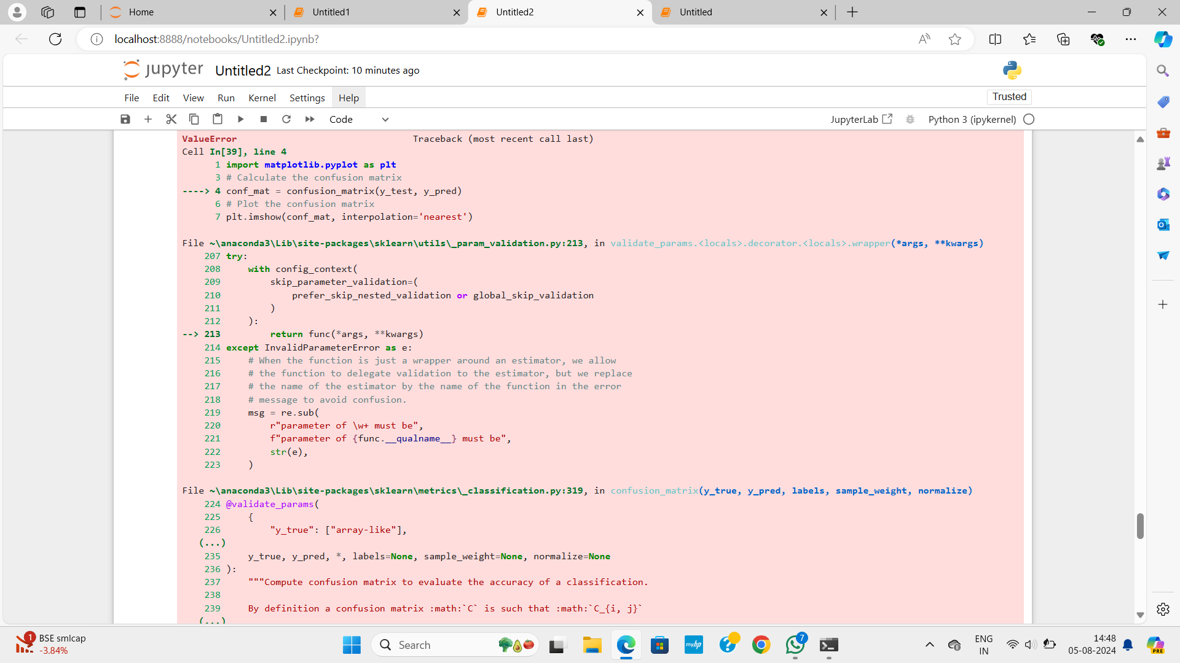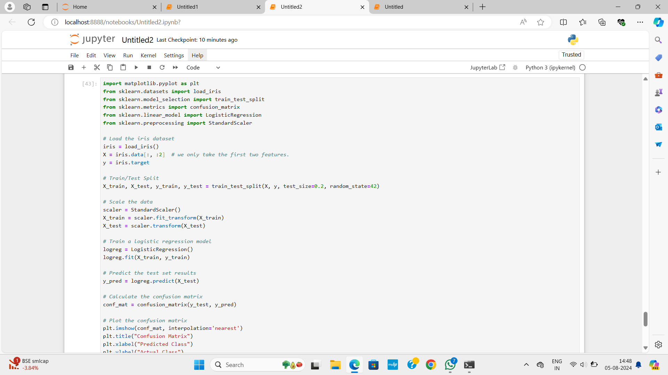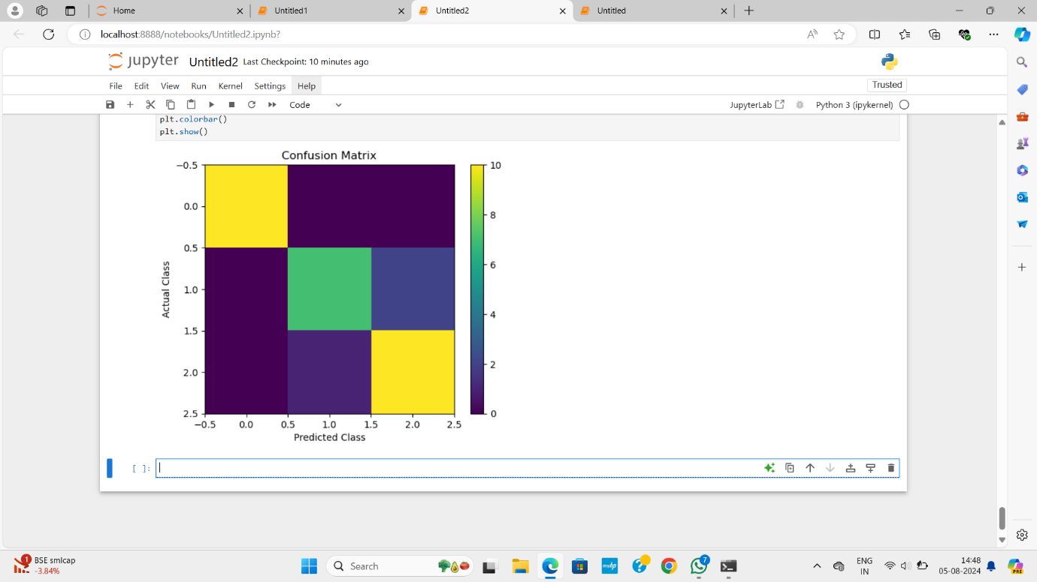

**PENGUINS_BINARY_CLASSIFICATION:**

**Code :**

    1.import numpy as np

import pandas as pd

2. dataset = pd.read_csv("penguins_binary_classification.csv") # first we need upload the dataset

dataset.head() # will shoe first 5 rows

3. x = dataset.iloc[:,0:1]

y = dataset.iloc[:,1]

x.head()

y.head()

4. from sklearn.model_selection import train_test_split

x_train,x_test,y_train,y_test =

train_test_split(x,y,train_size=0.8,random_state=42)

5. from sklearn.linear_model import LinearRegression

model = LinearRegression()

6.  model.fit(x_train,y_train)

7. samplepredciton = model.predict([[1240]])

print(samplepredciton)

y_pred = model.predict(x_test) # predicting for all x_test

y_pred

y_test

y_pred

list(zip(y_test,y_pred))

8. import numpy as np # Hypothetical housing dataset

areas = np.array([1000, 1030, 1060, 1090])  # House areas in square feet

prices = np.array([5618, 5201, 4779, 5245])  # House prices in dollars

# Example of a simple linear regression model (hypothetical coefficients)

m = 200  # slope

b = 50000  # intercept

# Make predictions

predicted_prices = m * areas + b

# Calculate squared differences

squared_diff = (prices - predicted_prices) ** 2

# Calculate mean squared error

mse = np.mean(squared_diff)

print("Actual Prices:", prices)

print("Predicted Prices:", predicted_prices)

print("Squared Differences:", squared_diff)

print("Mean Squared Error:", mse)

9.from sklearn.metrics import r2_score

r2 = r2_score(y_test, y_pred)

print(f'R-squared score: {r2:.2f}')

y_test

**Screenshots**

